**Digital Marketing Assignment -2**

|  |  |
| --- | --- |
| Student Name | Anna Lakshmi A |
| Student Register Number | 953720104006 |
| College Name | AAA College of Engineering and Technology |
| Naan Mudhalvan ID | CB8FDE3526945B59D454EE59062C6DE0 |

**Assignment:**

Create Facebook Business page and post one social media poster

**Solution:**

FACEBOOK PAGE

Link:<https://www.facebook.com/profile.php?id=61550613493645&mibextid=ZbWKwL>

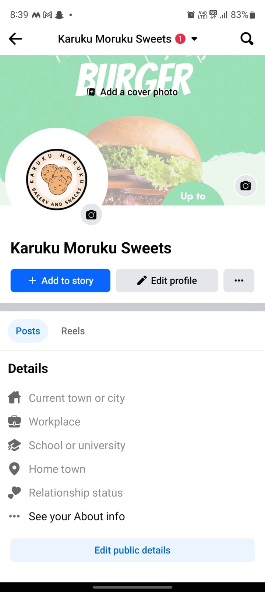

FACEBOOK POSTER

Link: <https://m.facebook.com/story.php?story_fbid=pfbid0mKPvoBC2jc8GHacFG1TBHvnGzj8SrYLndYVTPirMdF3eGBoZiVAjKyGv9YoQ9Hxdl&id=61550613493645&mibextid=Nif5oz>

